**Week 5_Microservices _HandsOn**

**Creating Microservices for account and loan**

**AccountApplication.java**

package com.cognizant.account;

import org.springframework.boot.SpringApplication;

import org.springframework.boot.autoconfigure.SpringBootApplication;

@SpringBootApplication

public class AccountApplication {

public static void main(String[] args) {

SpringApplication.run(AccountApplication.class, args);

}

}

**AccountController.java**

package com.cognizant.account.controller;

import org.springframework.web.bind.annotation.*;

import java.util.*;

*@RestController*

public class AccountController {

*@GetMapping*("/accounts/{number}")

public Map<String, Object> getAccount(*@PathVariable* String number) {

Map<String, Object> response = new HashMap<>();

response.put("number", number);

response.put("type", "savings");

response.put("balance", 234343);

return response;

}

}

**OUTPUT:**

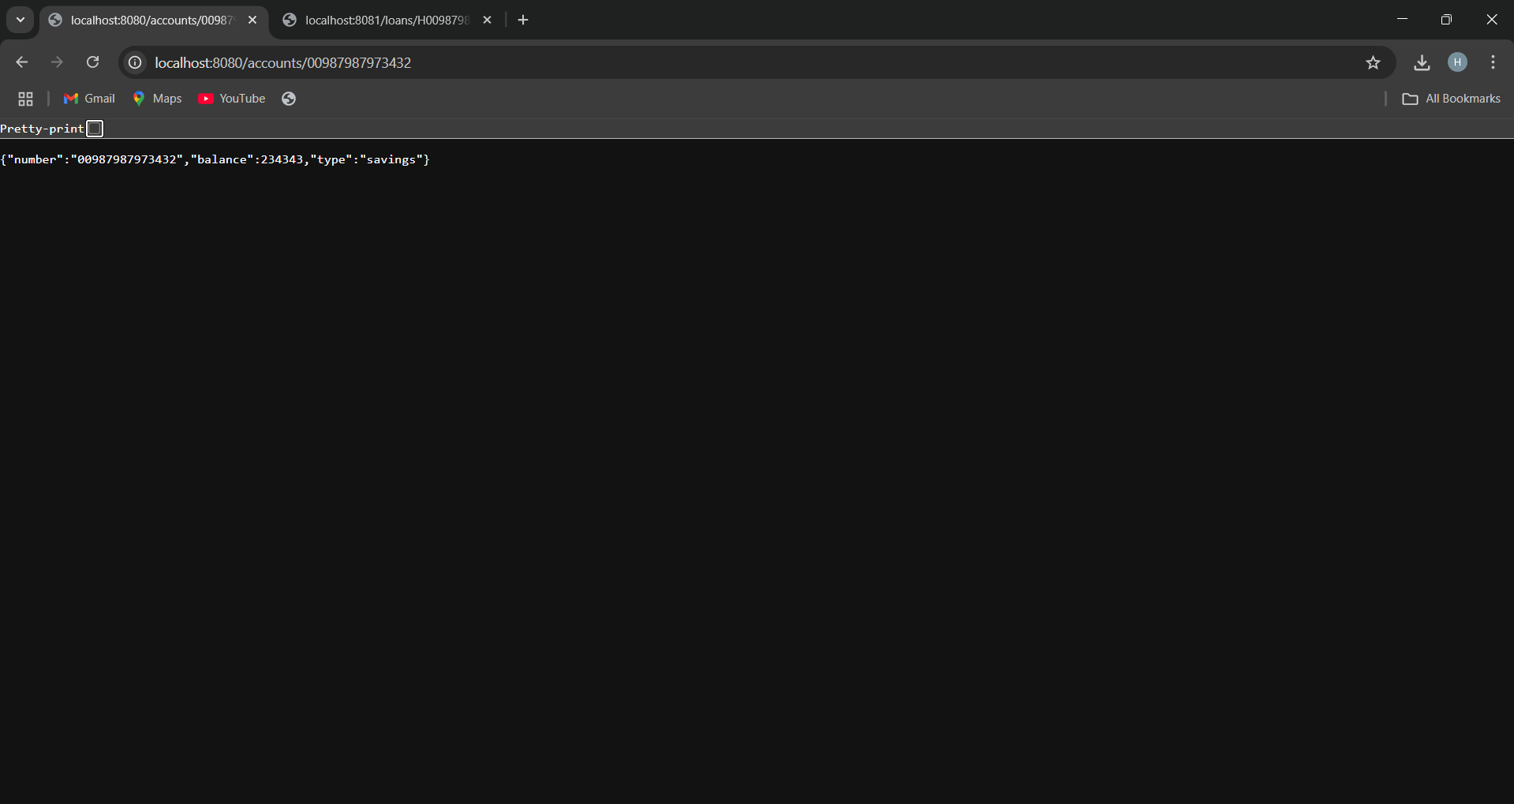

**LoanApplication.java**

package com.cognizant.loan;

import org.springframework.boot.SpringApplication;

import org.springframework.boot.autoconfigure.SpringBootApplication;

@SpringBootApplication

public class LoanApplication {

public static void main(String[] args) {

SpringApplication.run(LoanApplication.class, args);

}

}

**LoanController.java**

package com.cognizant.loan.controller;

import org.springframework.web.bind.annotation.*;

import java.util.*;

*@RestController*

public class LoanController {

*@GetMapping*("/loans/{number}")

public Map<String, Object> getLoan(*@PathVariable* String number) {

Map<String, Object> response = new HashMap<>();

response.put("number", number);

response.put("type", "car");

response.put("loan", 400000);

response.put("emi", 3258);

response.put("tenure", 20);

return response;

}

}

**OUTPUT:**

